ASSIGNMENT 3  ECHO SERVER USING TCP | Name: Nivetha Dhanakoti  Reg no.: 3122 22 5001 087

Aim:To Develop a socket program to simulate Echo Server.

Echo Server : The client sends data to server. The server in turn sends the message back to the client. Send multiple lines of text.

Sample Input Output
Client Side
Client: “hi this is from ssn.
------------------
------------------“
Message from Server: “hi this is from ssn.
------------------
------------------“

Server Side
Message from Client: “hi this is from ssn.
------------------
------------------“
Message sent: “hi this is from ssn.
------------------
------------------“

Code:
Server
#include <stdio.h>
#include <sys/types.h>
#include <sys/socket.h>
#include <netinet/in.h>
#include <string.h>
#include <unistd.h>
#include <arpa/inet.h>

int main(int argc, char **argv)
{
socklen_t len;
int sockfd, newfd, n;
struct sockaddr_in servaddr, cliaddr;
char buff[1024];

sockfd = socket(AF_INET, SOCK_STREAM, 0);
if (sockfd < 0)
{
perror("cannot create socket");
return 1;
}

bzero(&servaddr, sizeof(servaddr));
servaddr.sin_family = AF_INET;
servaddr.sin_addr.s_addr = INADDR_ANY;
servaddr.sin_port = htons(7777);

if (bind(sockfd, (struct sockaddr*)&servaddr, sizeof(servaddr)) < 0)
{
perror("Bind error");
return 1;
}

listen(sockfd, 2);
len = sizeof(cliaddr);

// Receiving messages
while (1)
{
newfd = accept(sockfd, (struct sockaddr*)&cliaddr, &len);
if (newfd < 0)
{
perror("Accept error");
return 1;
}

while (1)
{
n = read(newfd, buff, sizeof(buff) - 1);
if (n < 0)
{
perror("Read error");
close(newfd);
return 1;
}
else if (n == 0)
{
// Connection closed by client
break;
}

buff[n] = '\0'; // Null-terminate the string
printf("Received Message: %s\n", buff);

if (strcmp(buff, "END") == 0)
{
close(newfd);
break;
}
}
if (strcmp(buff, "END") == 0)
{
break;
}
}

close(sockfd);
return 0;
}

Client
#include <stdio.h>
#include <sys/types.h>
#include <sys/socket.h>
#include <netinet/in.h>
#include <string.h>
#include <unistd.h>
#include <arpa/inet.h>

int main(int argc, char **argv)
{
int sockfd, n;
struct sockaddr_in servaddr;
char buff[1024];

if (argc < 2)
{
fprintf(stderr, "Usage: %s <server-ip-address>\n", argv[0]);
return 1;
}

sockfd = socket(AF_INET, SOCK_STREAM, 0);
if (sockfd < 0)
{
perror("cannot create socket");
return 1;
}

bzero(&servaddr, sizeof(servaddr));
servaddr.sin_family = AF_INET;
servaddr.sin_addr.s_addr = inet_addr(argv[1]);
servaddr.sin_port = htons(7777);

if (connect(sockfd, (struct sockaddr*)&servaddr, sizeof(servaddr)) < 0)
{
perror("Connect error");
close(sockfd);
return 1;
}

// Sending the message
while (1)
{
printf("Enter the message: ");
if (fgets(buff, sizeof(buff), stdin) == NULL)
{
perror("Input error");
close(sockfd);
return 1;
}
buff[strcspn(buff, "\n")] = '\0'; // Remove newline

n = write(sockfd, buff, strlen(buff) + 1);
if (n < 0)
{
perror("Write error");
close(sockfd);
return 1;
}

if (strcmp(buff, "END") == 0)
break;
}

close(sockfd);
return 0;
}

Output:
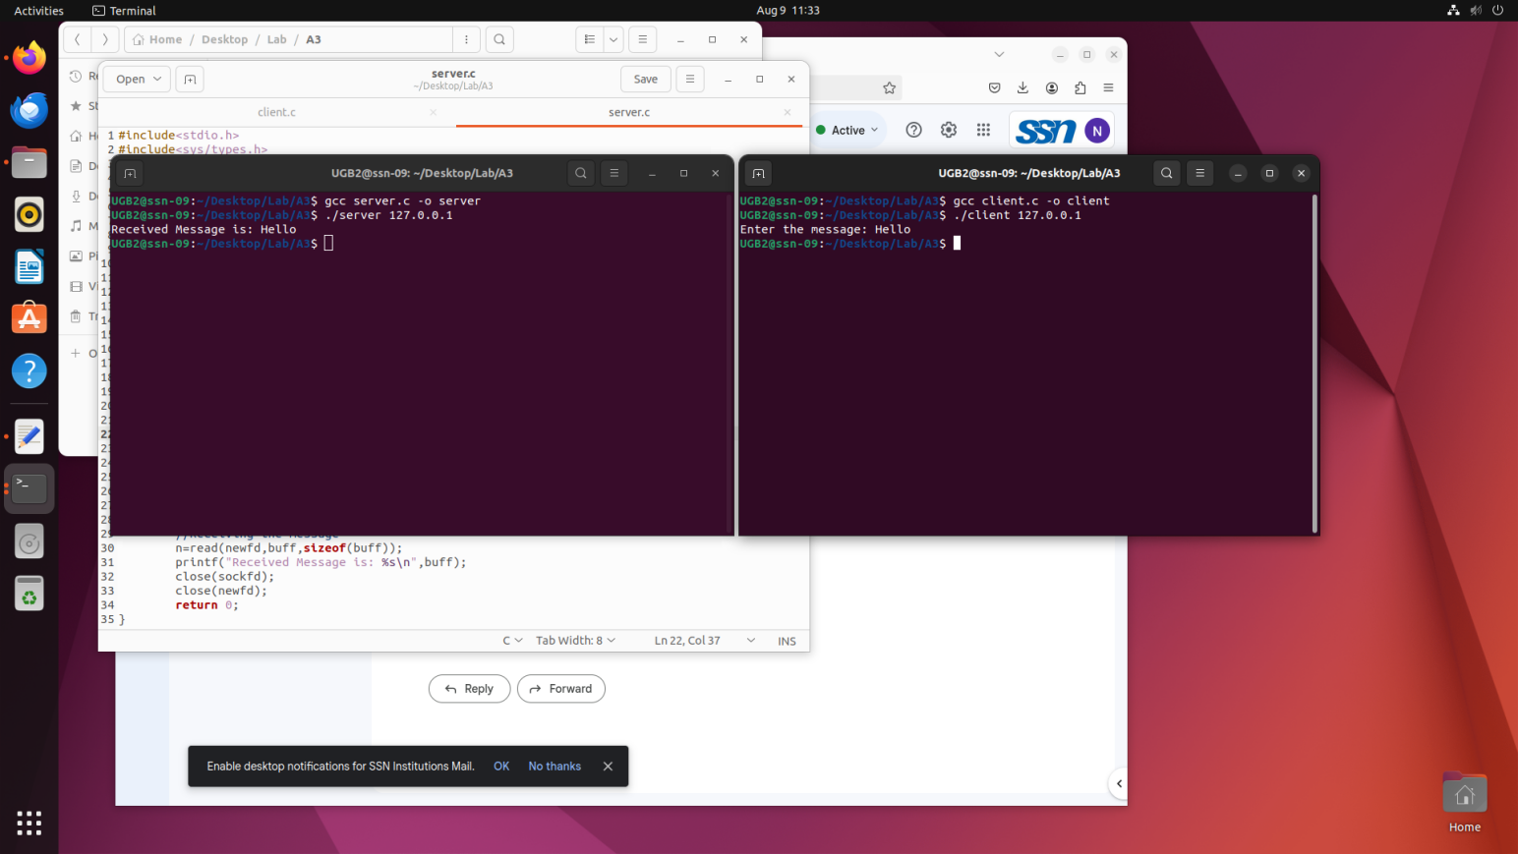

Server Output:

Client Output:

Learning Outcomes:
I have learnt to be proficient in developing socket program through echo server.

